Seminar Sheet 5
We have considered how inheritance, classes, structs and general data behave in C++. This seminar sheet is a culmination of all the past weeks of work undertaken. Combining elements form each to be able to create a complex system, that is common in a number of games. In previous worksheets we looked at items, and actors and components and how they function in unreal engine. The aim of this work sheet is to create an inventory system to store, manage and handle objects and items in the game world. You will need to consider how your game will handle items and the plyaer owning them. Are items unique, can they only spawn once, and never again. Can you have stacks? You may want to design a simple inheritance hierarchy for the items in your game. You may want to consider whether to type them with enums instead. You can choose to implement this seminar sheet in either blueprint, C++ or both.

Problem 1.
  - Design a set of in game items or collectables, outline the types of statistics you want to record, how will you handle the diﬀerent items, and how do they ﬁt into your game world / idea. Use UML diagrams to explain the diﬀerent types of items you want to represent.
A simple UML setup, I just considered a couple main type of items that would occur in most games and broke down the UML based on them, they would act differently.
The Crafting Items has no childern since its very much just various different types with no addition variables or functions since another component should handle them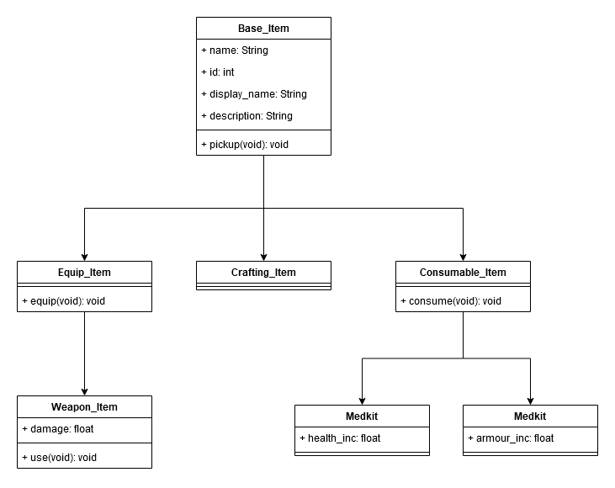

Problem 2.
  - Implement and create multiple items that can be picked up and collected by the player. Place them in the world, and allow the player to run over and collect them. (Do not worry about storing them yet). You may want to have them randomly spawn in your game level, or you may want to place them. You may want to create an item spawner, consider how a designer might interact with this. (You may want to seek inspiration from DND or RogueLikes etc.)
Creating the Item Base in CPP to include some CPP element, better to manage changes and control the base, I want to add item rotation to spawn items in the future as well in the CPP actor
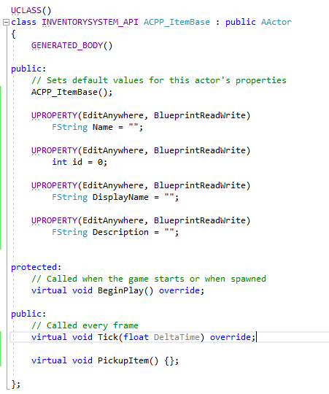
From the CPP Base I created blueprints inheriting this and constructed a few basic items based on the UML, implementing the functions along with this and variables to cover them before moving forward
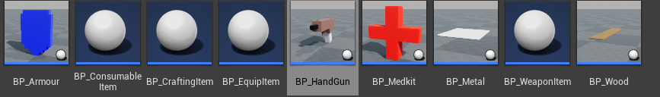
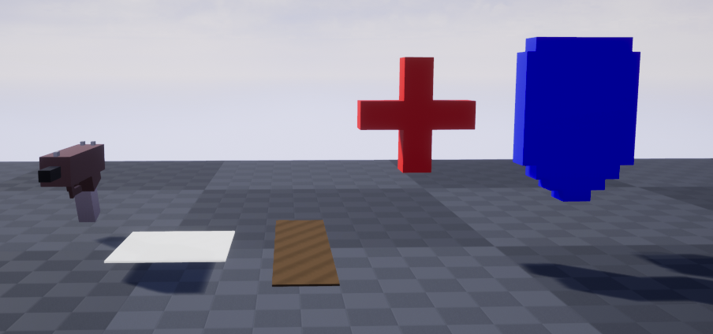

Problem 3.
  - Design the Inventory system in UML, present a ﬂow diagram for show casing how you for see your API being called. Create an inventory system. This is required to store the item and it’s current quantity. Design and implement an API to deal with adding and removing items, etc. Justify the various functions you may need. Consider how your player class / player controller may want to interface with this system. Hint: Research a simple Inventory system, and consider how this can inform your API design.
Taking a look at a simple inventory system, way of representing a basic stack as a struct and then plugging that into the Inventory, from there the interaction the Inventory system would be done via the player controller and possibly the UI
The Interact function has no need to provide and input or output, any detected items during the interact call should run other function instead
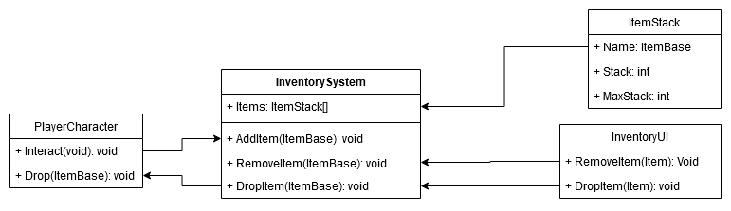
Implementing the Basic Struct based on the UML
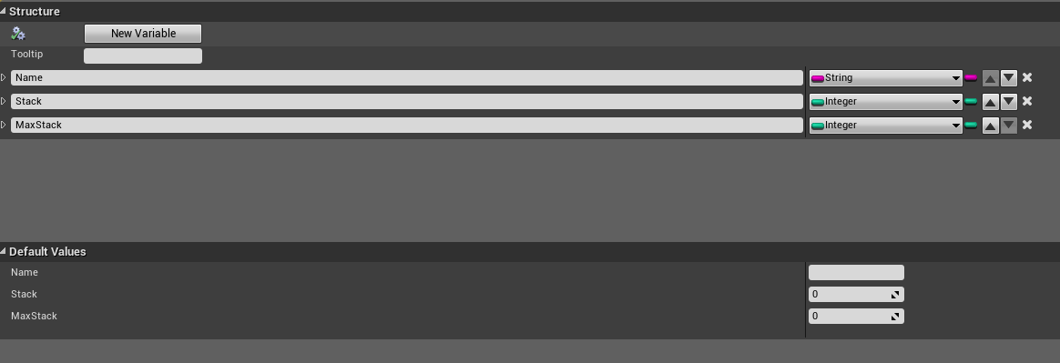
Implementing the InventoryComponent Add Item Function
This can support multiple stacks of the same item (default max is 50)
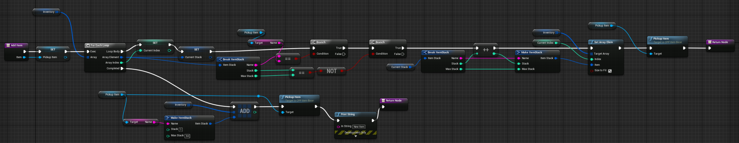
Attaching the InventoryComponent to the Player Character
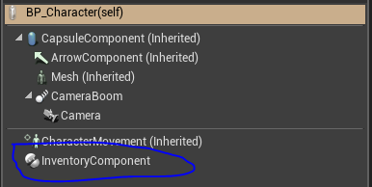
Now basic pickups are implemented, simple test to see if by picking them up they can all appear in their stacks.
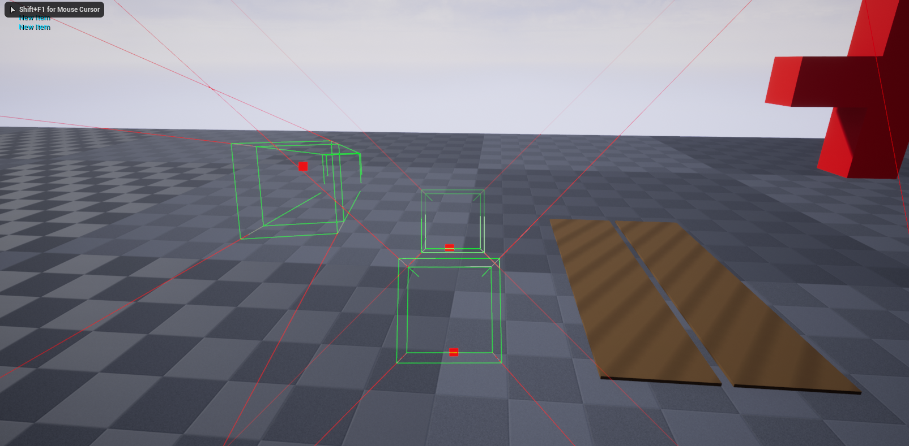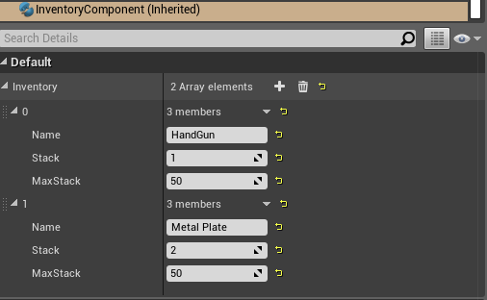
With that test working and the remaining items also get correctly placed, time to test multiple stacks of an item, the Add Item function already should handle this so its just a matter of starting off with a full stack.
Another area to look at is setting something to manage the stack default since it’s ridiculous to hold 50 handguns.
Following this run through, a stack of wooden panels are created with the stack since equal to the maximum
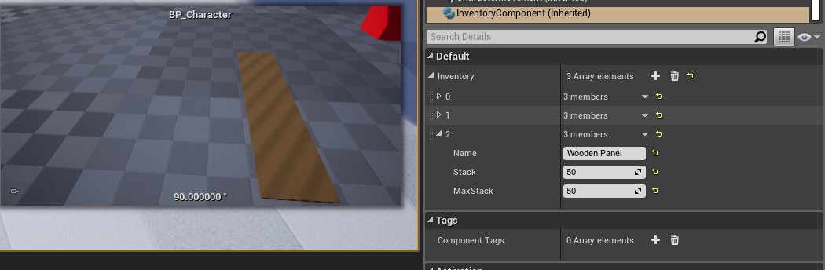
Finally picking up the second wooden panel shows a new stack correctly being made
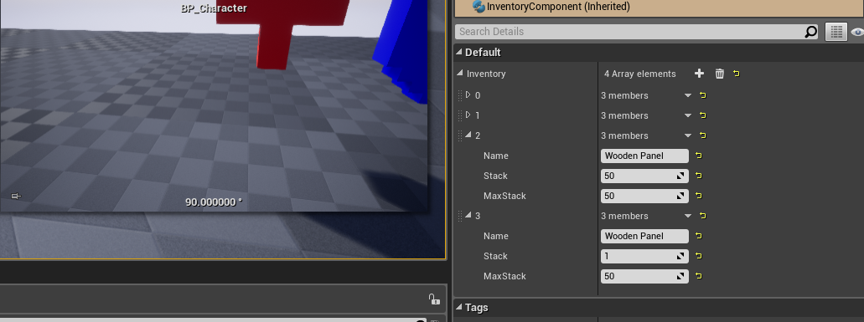
Next is looking at removing items, the only best way to do this is to make the item stacks accessible or visible within the game, the only way see this is by creating UI to show this.
Knowing that Problem 5 is about UI my UI intends to just display the items and a means of removing them. Ignore the other parts of problem 5 that I’ll do once I reach that point
I have done slight exploration with UMG and creating UI Icons but through experimentation with my before Inventory System Attempts, the passing of textures failed. (View in failed folder)
The best way going forward is to operate with a Text Based UI system but something clean but informative (Nier Automata is a good example)
Forgetting to go over the initial inputs for this project, E is to Interact and TAB is to open the UI (Which I just added now)
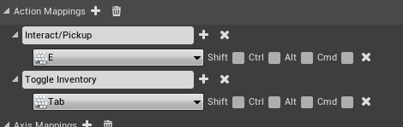
Some quick implantation from what makes sense lead me to making the basic HUD components
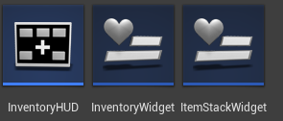
The InventoryHUD handling the showing and hiding of the UI Widgets
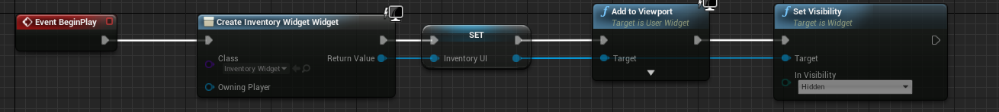
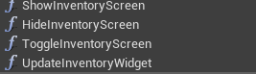
ToggleInventory
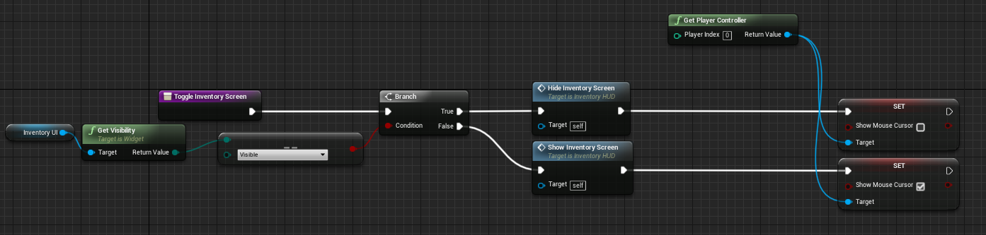
ShowInventory
This method sets input to Game and UI to still allow input to work, I’ve not been able to get the input to work on just UI mode
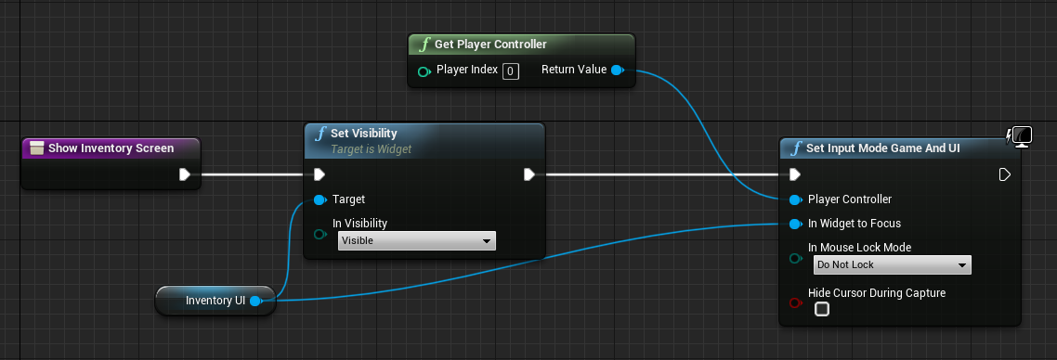
HideInventory
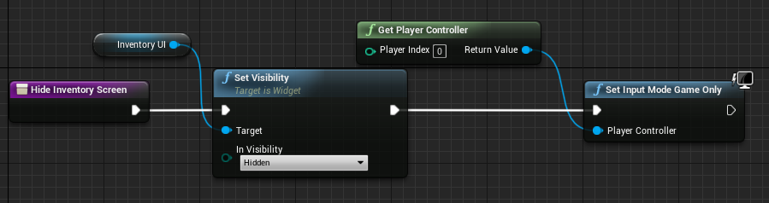
PlayerController’s Input Handler
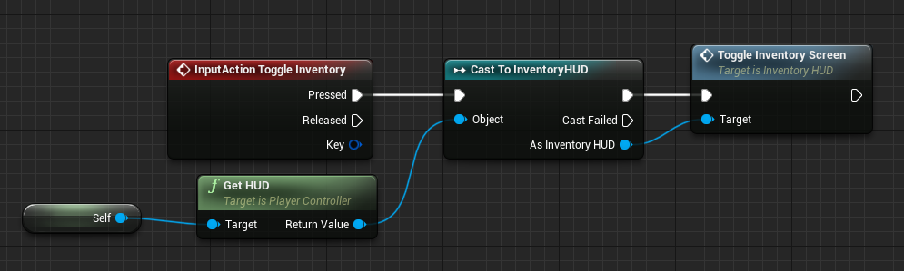
Creating the Item UI Row simply showing the name and quantity
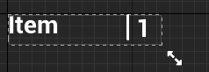
Bindings are set up for the EntryWidget
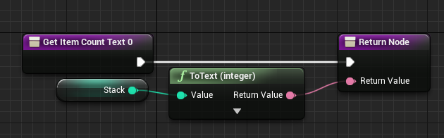
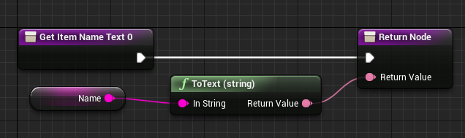

Using the ListView Widget it should turn out like this
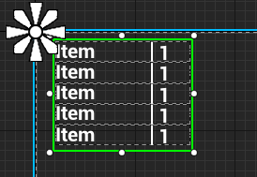
Basic UI is done and now to test it, collecting all items placed on the map my first try doesn’t go well
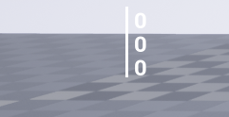
There should be 5 stacks showing all different items with either 1 or 2 items stacked so all I know now is that the widget is getting the info right
Some small investigation I should update the list when making the inventory UI visible so now atleast I can see 5 slots like I should, the name and stack numbers are not working though
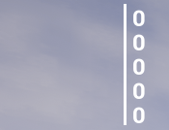
A quick test helped me discover something after picking up a single item I’m not dealing with the same UI widget as the one I pass the values of the item name and stack to, show by trying to get the display name of a widget at different points of adding the item
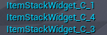
This problem I’m dealing with was the same issue I had with texture Icon, which means I’m generally just missing a step completely and doing something wrong
With much research and experimentation I’ve solved the problem, my understanding of listview and entry widgets was wrong and I jumped a step. Time to explain…
My initial understanding with UI bindings is creating a binding and attaching it to a method or variable in a UI element would be all that was needed
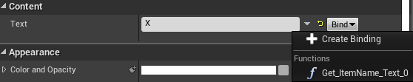
This binding in the entry widget should do what I needed but that’s where the whole problem occurs
UI entry widgets do not refer to themselves when displaying (hence seeing multiple widgets under their display names)
When adding an item to a list view it creates the defaulted entry widget set here
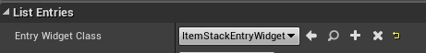
What I thought was this sets the class type and I’m to manually add a new entry widget each time
(Ignore the red lines, I’m explaining this as I fixed the issue but assume that the entry widget required these variables)
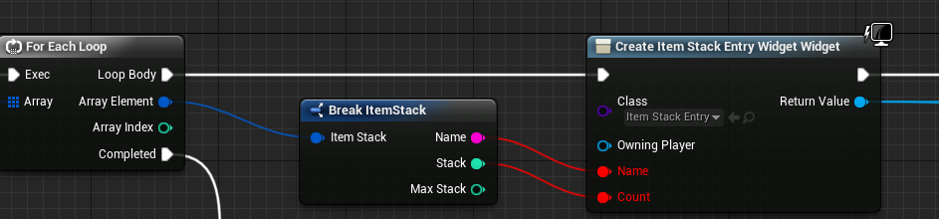
Which is wrong
I then thought that adding the widget to the item field when adding a new list item is how to go about things and I refer to the object from the methods inside the entry widget I’ve set up
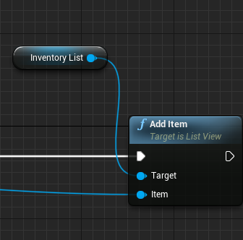
This is wrong as each time I call “Add Item” to the list it creates its own Entry Widget internally, the item field there serves as a way of passing an object to provide variables to the internally made entry widget, and my mistake was passing in another entry widget instead.
I was so happy about figuring it out I made a simple diagram to show my mistake, the UI shows the box under “Binding Get” but I wanted it to receive what was under “Trying to get”
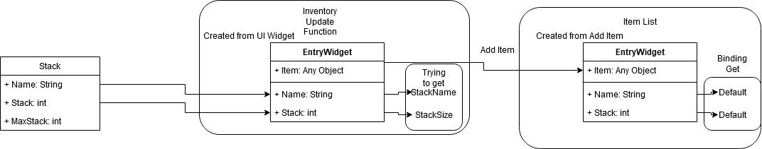
Understanding the issue I could refactor parts to full solve this, to save time I did not go through a whole process. I made another blank widget with its role of carrying the data as an object
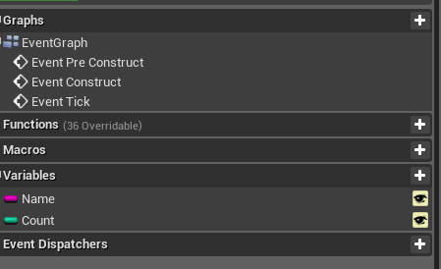
This is then the “Carrier” for the data and is sent into the new item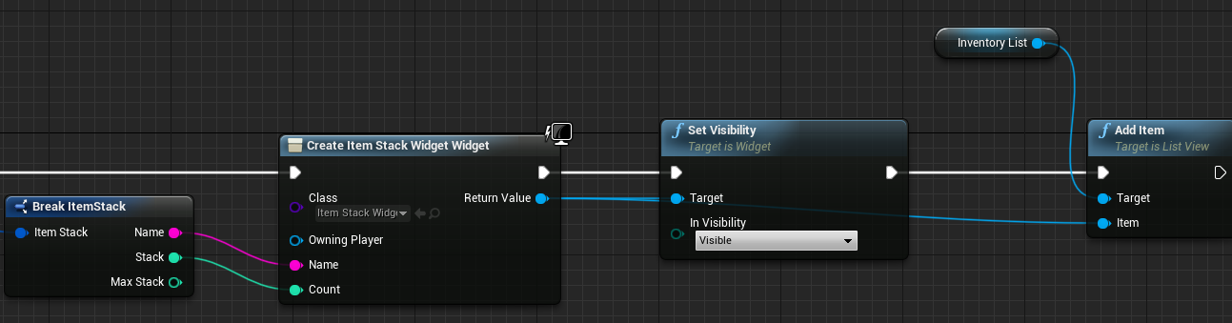
Now into the binding I can tell it to retrieve the object from itself and set the relevant data as the binding output
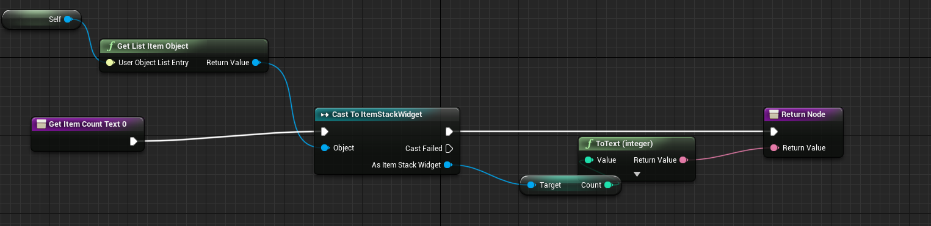
The Result
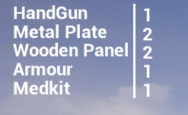
Picking up items correctly display the stacks. With this understood it would be the same process if I wanted to do UI elements, but for now I’ll leave that lone

Problem 4.
  - Plugin the functionality from earlier where a player could overlap with items in the world. Allow them to run over and collect items place or spawned, and update the inventory with the relevant information. Can you setup a test scene to ensure that you have programmed this system correctly? Does the player have a limited inventory system? Do they have max stacks of a particular item?

Problem 5 (Extension).
  - Consider how you could design a simple UI to display your Inventory. What simple functionality can you provide to the elements in this UI. Drop items, merge stacks, split stacks.

